**All four IP Addresses**

|  |  |
| --- | --- |
| **ANSIBLEIP** | **52.214.175.111** |
| **DOCKERIP** | **34.244.190.104** |
| **JENKINSIP** | **3.252.104.2** |
| **SONARIP** | **54.217.133.43** |

We ssh into all four IP to check if their UserData is running properly

**ANSIBLE:**  
We ssh into ansible and did a ping all to see if our host file is updated and the output should contain Docker IP which is correct, see below   
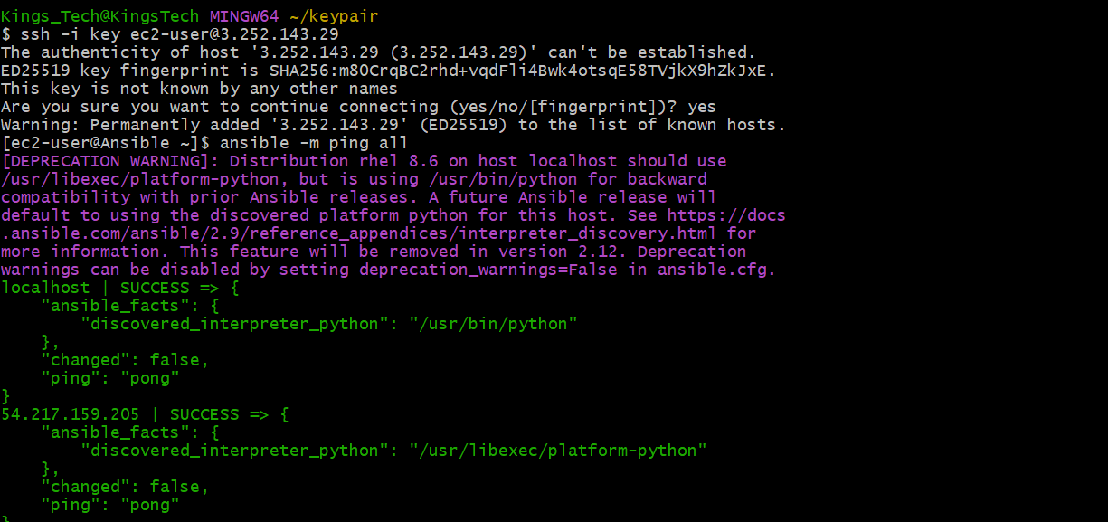  
sudo cat /etc/ansible/host contains the docker host ip and private key  
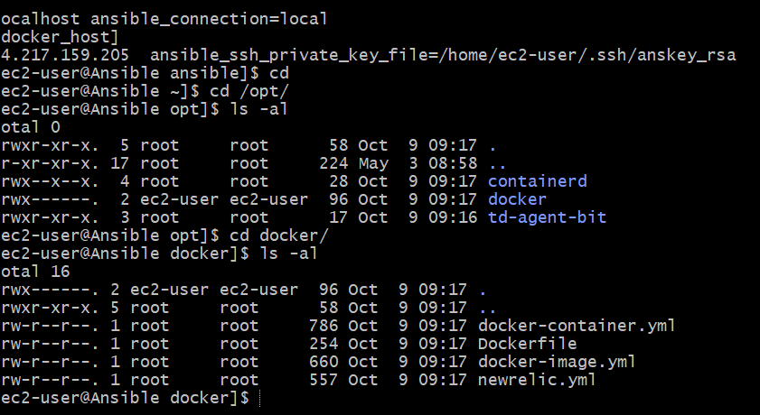

Furthermore, we have our playbook which we created through userDATA using scripts which are contained in /opt/docker/

**Jenkins:**  
Jenkins is up and ready to configure and help us build

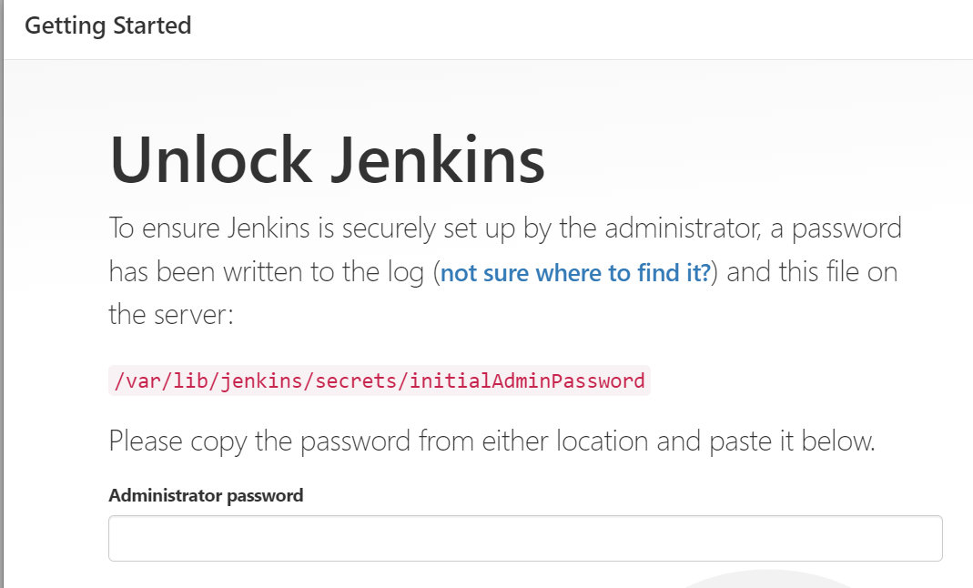

Config:

1. Manager Jenkins  
   Manager plugins=Available> SSH, SSH AGENT, Maven Integration, SonarQube Scanner.
2. Global Tool Configuration= Maven (name as maven{save})
3. Manage Credentials= Global
4. Username with password: (Github username and Token)  
   This purpose allows your Jenkins to pull code from git repo
5. Ssh username with priv key(reason for this is for Jenkins to connect to ansible)  
   So for this purpose, I created a key in my Jenkins and copied the private key to ansible authorised key.  
   Then copied the private key and pasted on Jenkins web.
6. Secret Text=Global (Jenkins, nodde…)  
   For this purpose I generated a token on SonarQube (Admin-User)
7. Configure systems   
   i. SonarQube  
   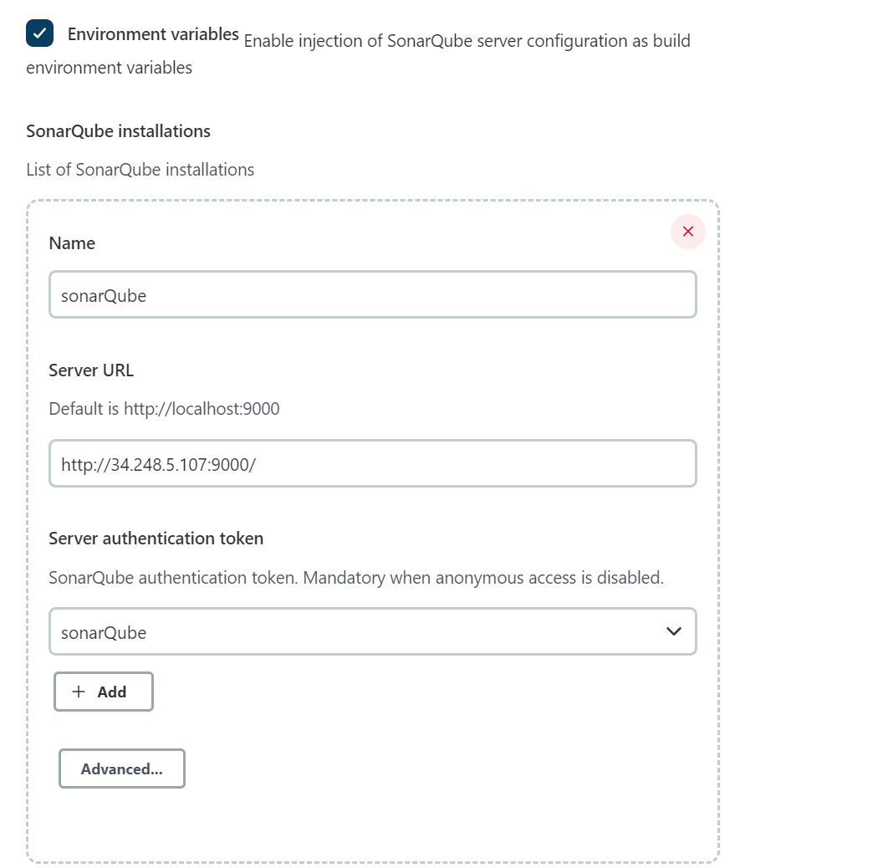  
   ii. Ssh remote hosts  
   Here we add ansible ip address and check connection  
   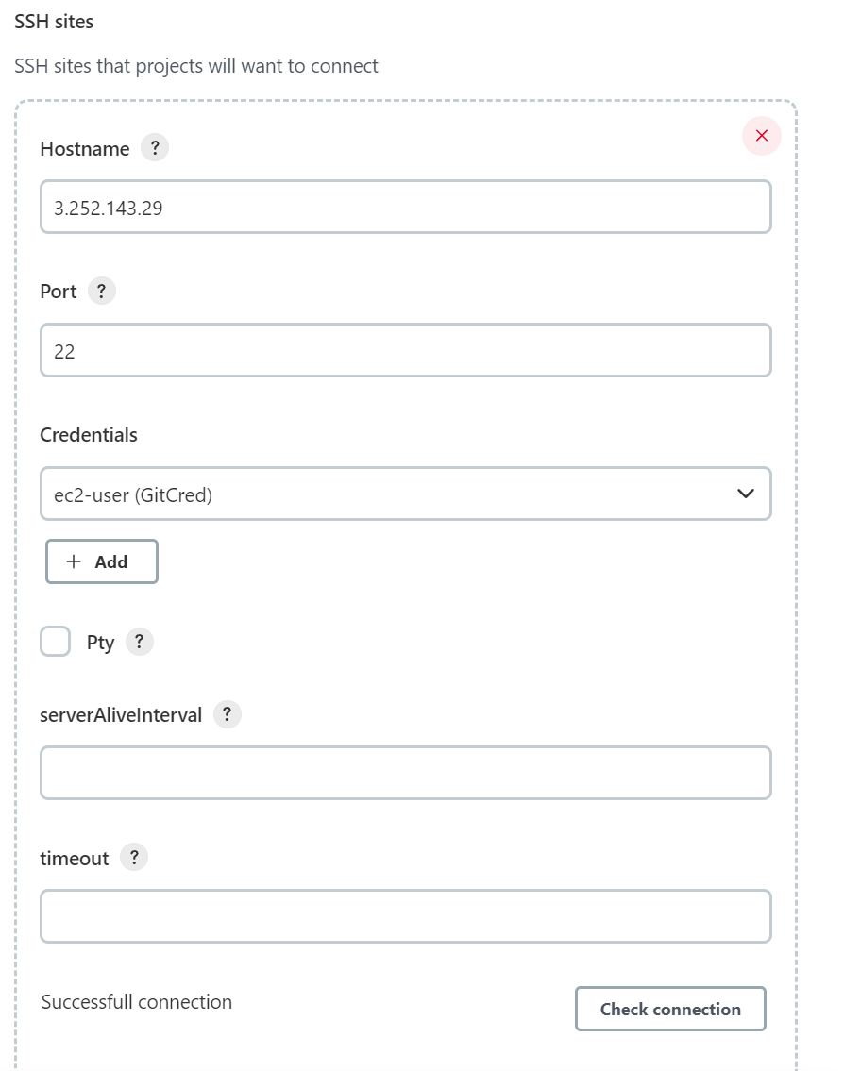

In Jenkins Terminal, we created a Jenkins key and added the pun key in ansible authorised key, which helps Jenkins be able to ssh into ansible, this would allow jenkins pass the war file when it is been created.  
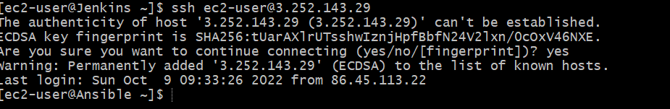

Create a Job

Name your job name and go to pipeline and click on pipeline script from scm

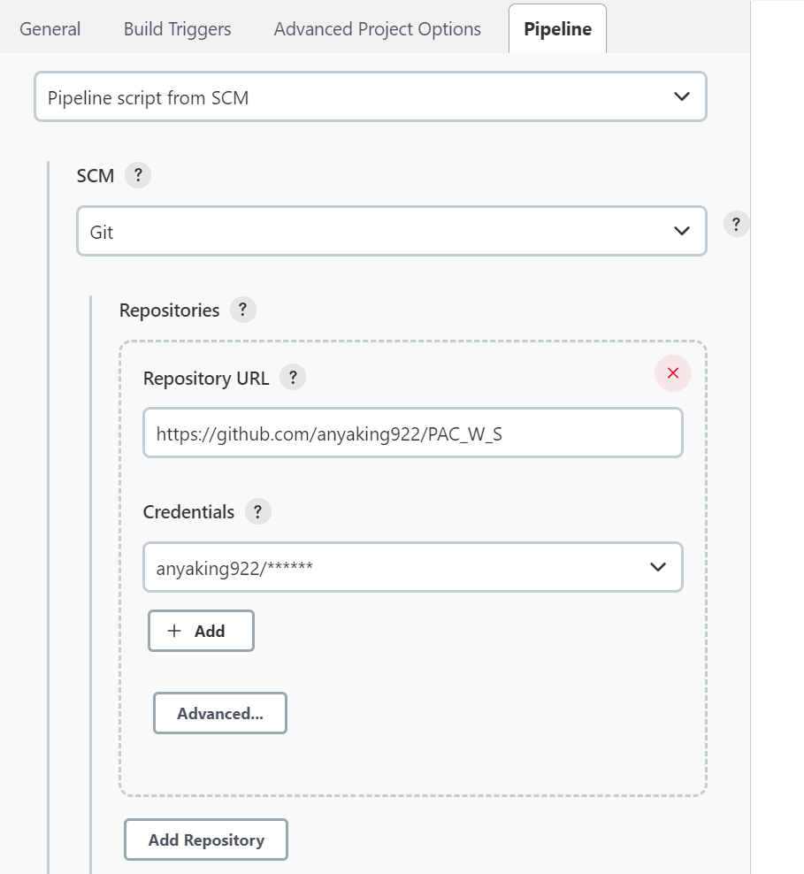  
Branch is according to how many are using the branch, mine is mine  
  
The second job, we add playbooks and click on build after other projects are built and it is triggered only if build was stable (Successful)

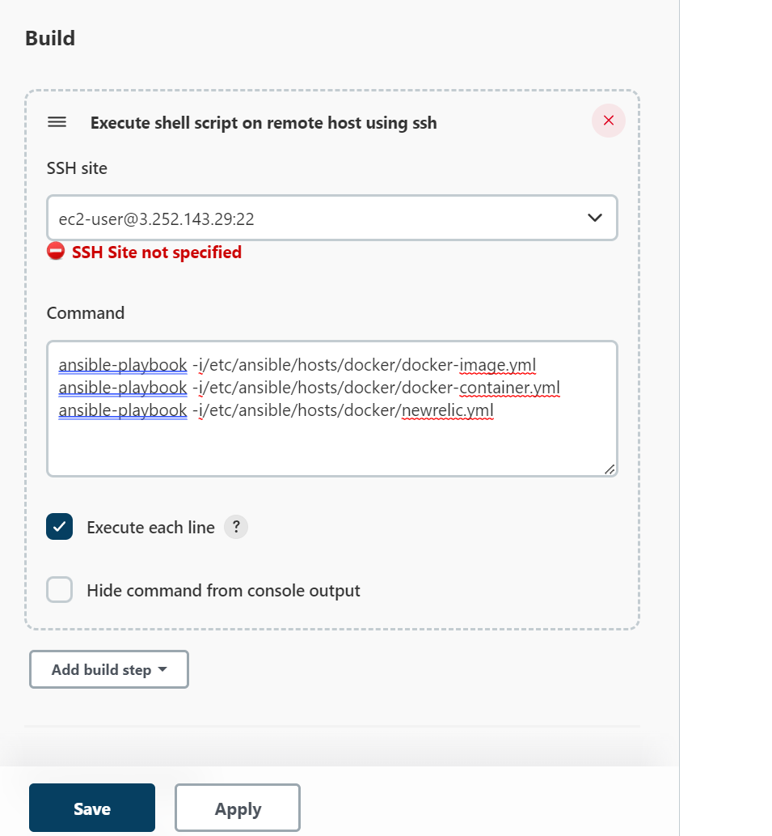  
Then apply and save

**SonarQube:**

It is up and ready for configuration

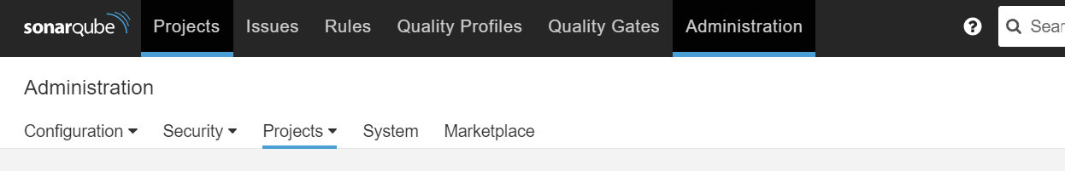  
We navigate to Administrator, webhooks, we create a Jenkins webhooks and add Jenkins URL

Building On Jenkins:  
On Jenkins Board, we have two jobs we ran using the Jenkins script on github.  
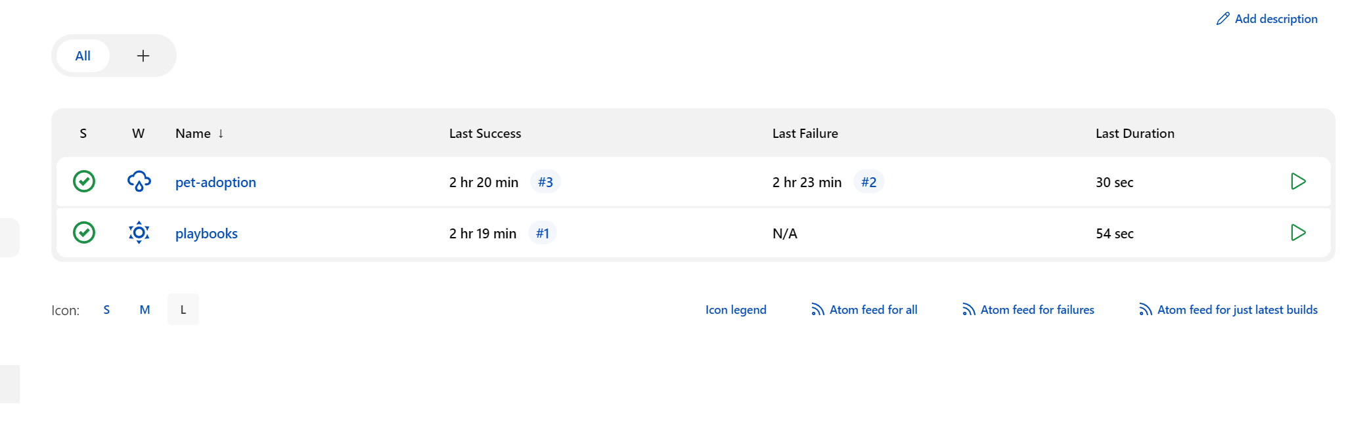

The First Job (PetAdoption) is created as a pipeline job which is connected to GitHub account which triggers once there is a commit on GitHub

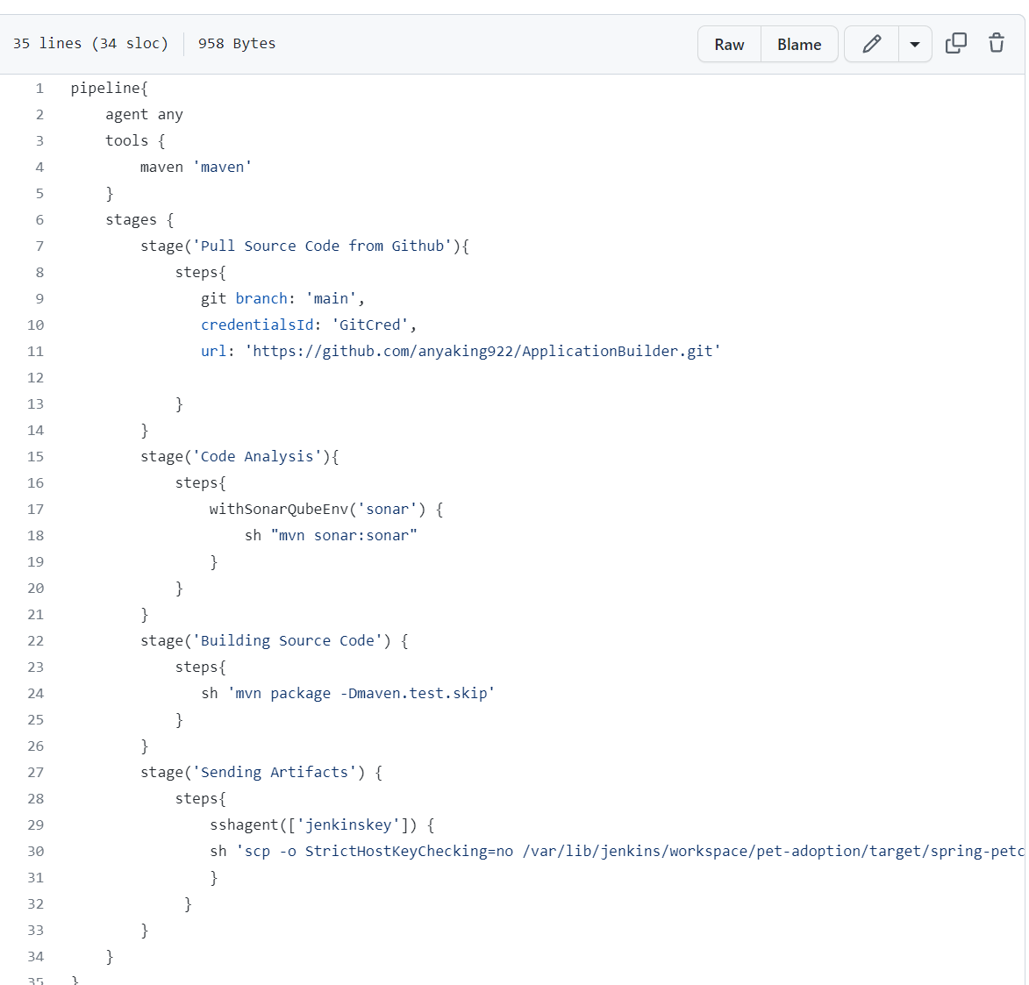

As you see above, the Jenkins file has stages on which it is built and deployed, see below

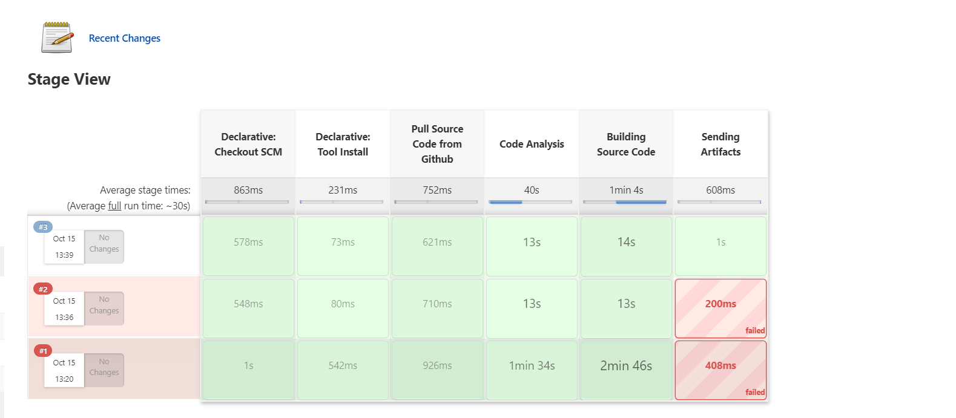

As we can see, it goes in stages, Declaractive tool install (maven, SonarQube, Ssh Agent), it builds from source code (GitHub: as we have supplied the git repo during configuration), sonrQube analysis as we connected SonarQube scanner, it builds and send Artifacts to Docker

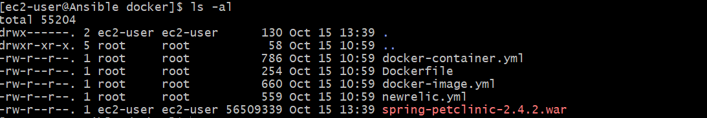

Job2: It is Playbooks  
And the work of the playbooks are different, one logins into docker to cop our image, one containerises it and the deploy to webserver.

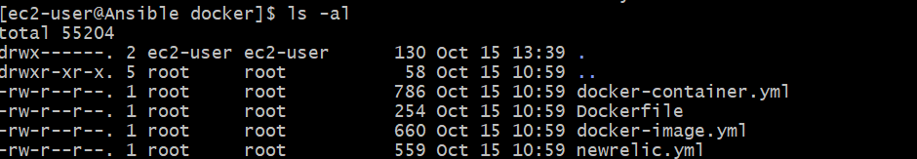

On deployment, we get this homepage using DockerIP:8080

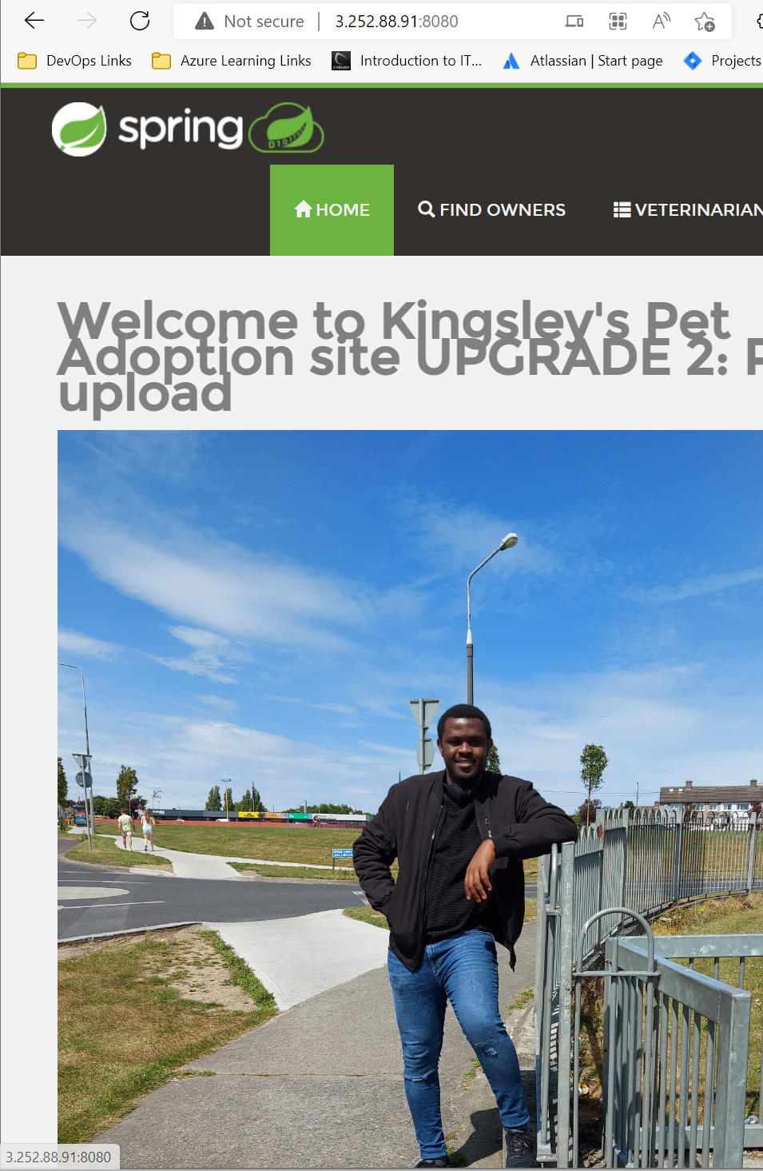

We reapply the terraform code to get our ALB and most importantly move our deployment to various autosclaed instance to reduce traffic on our main instance (DockerIP).

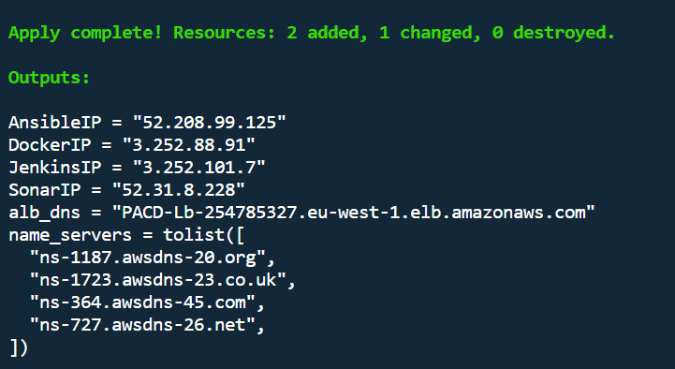

**Result:  
Aws DashBoard  
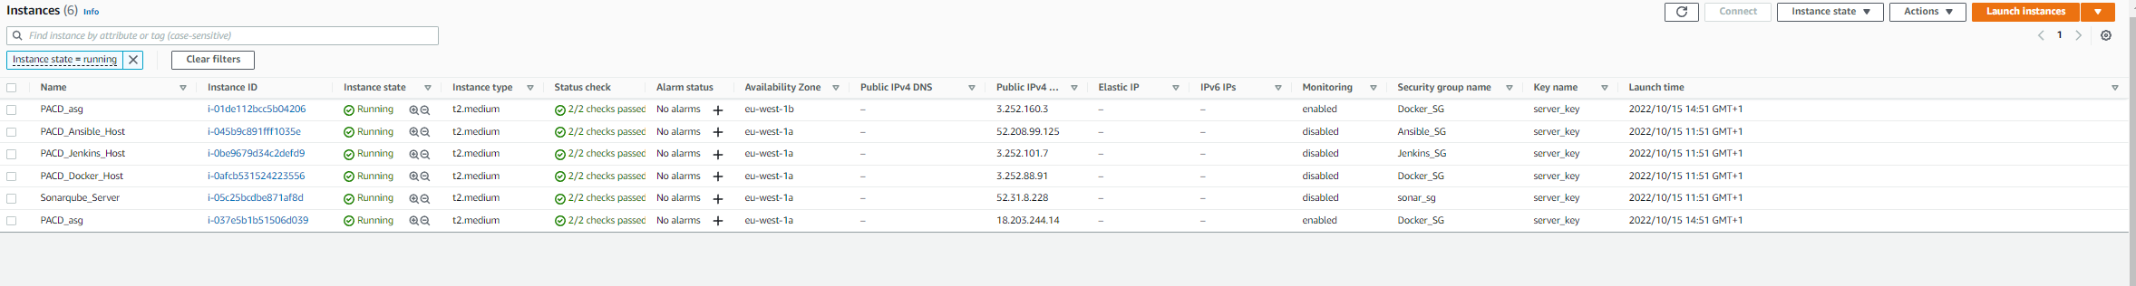**On the dashboard, you can see that we are autoscaling our adoption to two instances and zone (1a & 1b {Ireland [eu-west]})

**Working URL:**  
Docker IP: <http://3.252.88.91:8080/>



Application Load Balancer: <http://pacd-lb-254785327.eu-west-1.elb.amazonaws.com/>

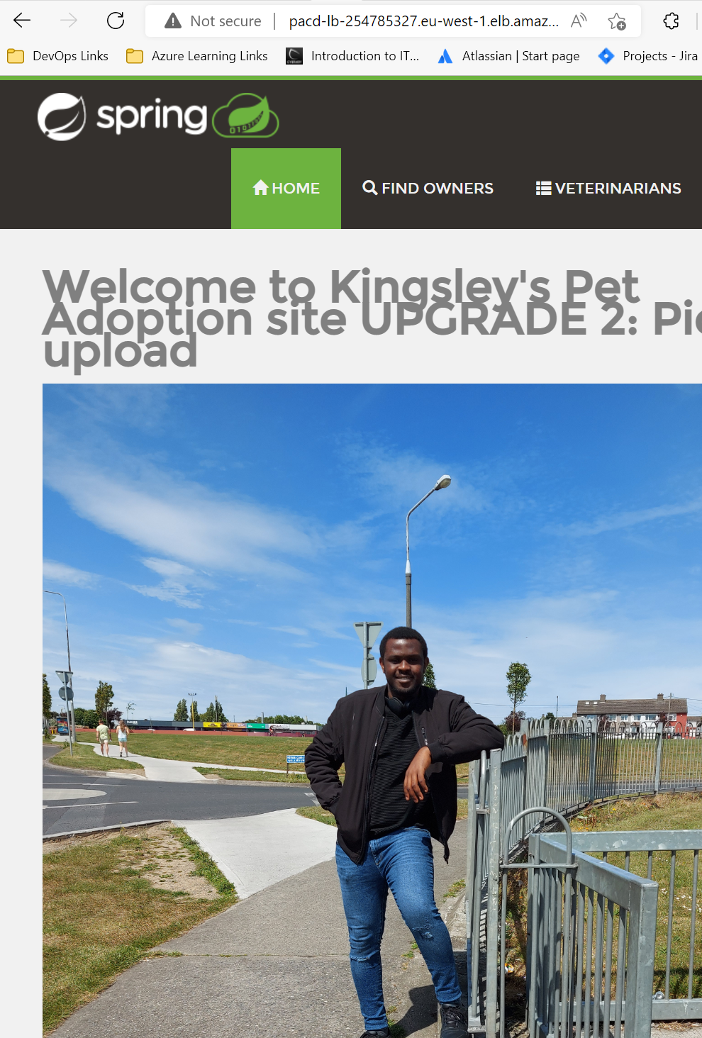

**Auto Scaled Instances**

1. West1b…<http://3.252.160.3:8080/>

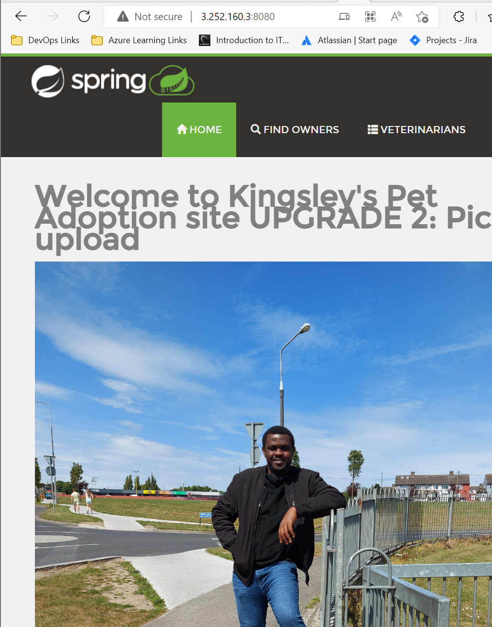

1. West1a: <http://18.203.244.14:8080/>

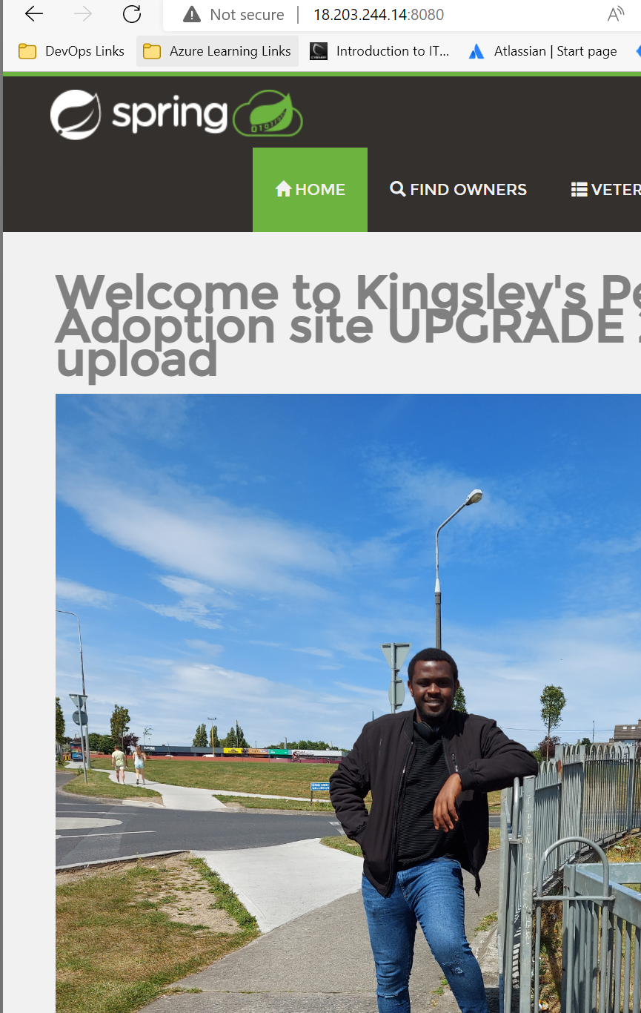Domain (anyaking.com)  
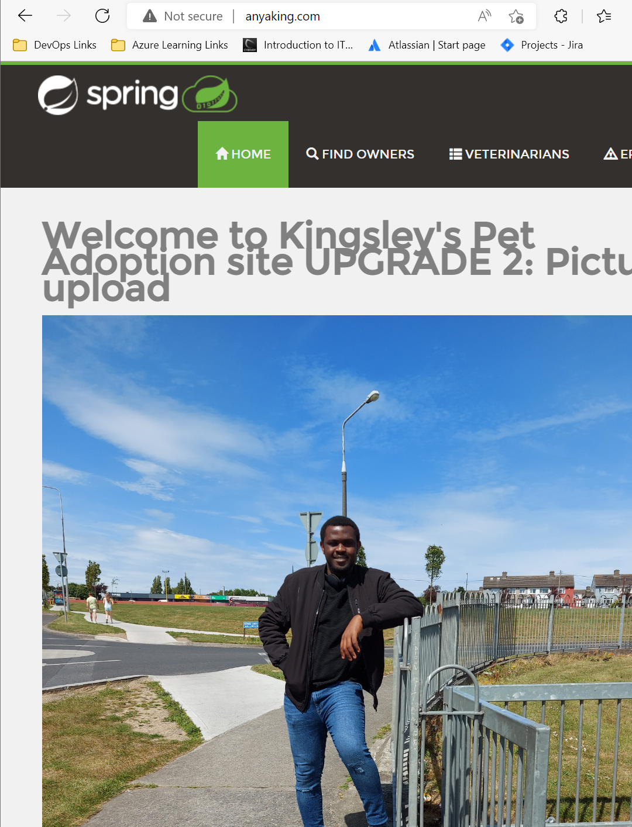

Upgrade (Update):  
Deployment is automatic because we conjured a webhook on github using Jenkins URL, which check on our github always to see new commit.

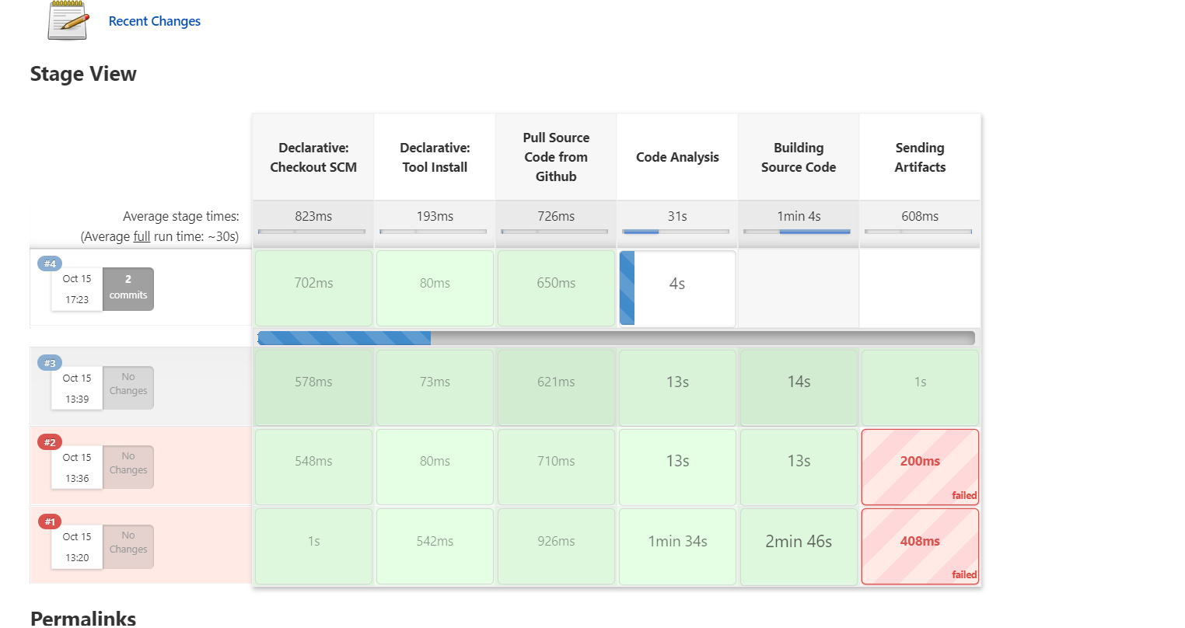

And it was a success and the second job started building immediately

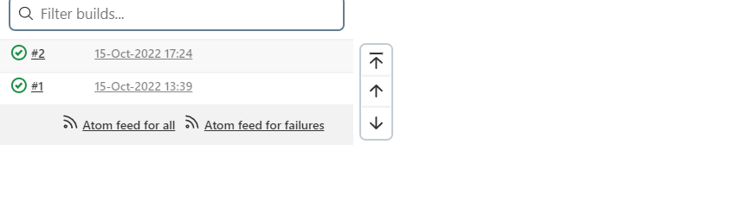

And if we refresh all our webpages, it would come with the new commits

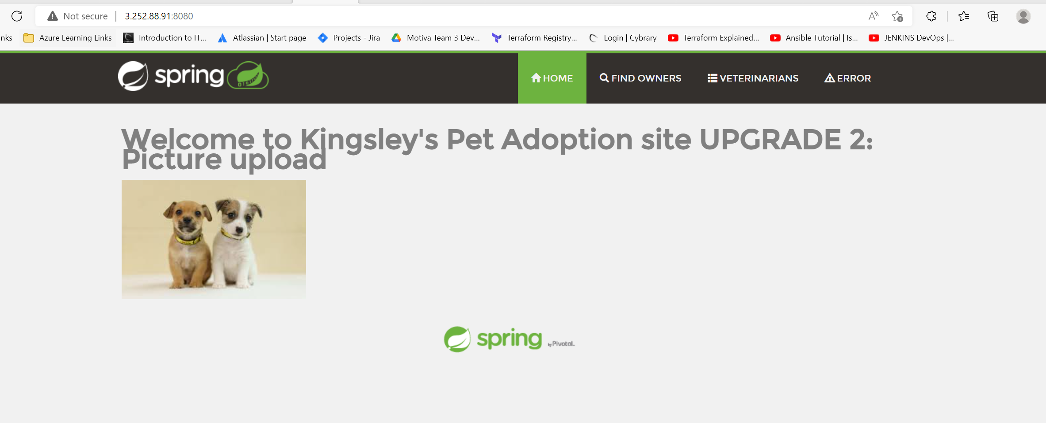

Same goes to all other URL.

Git

https://github.com/anyaking922/ApplicationBuilder.git (deployment hub)

https://github.com/anyaking922/Project01_petAdoption.git (code)

Consequences  
a. SonarQube version 9 is not compatible on JavaVersion 11.

b. So I am downgrading sonarQ to version 8, for it to be able to work.

c. My github and Docker is having issues in this deployment.

Future Work:  
To Automate all processes fully